VIET HUNG SECONDARY SCHOOL  SCHOOL YEAR: 2019 – 2020 | FIRST TERM TEST  SPEAKING TEST – GRADE 6  No 1

Part I: Introduction (0.5 pt)
Introduce yourself (name, age, school, class)
Part II: Interview (0.5 pt)
What is your favourite subject at school?
There are three schools here. Which school would you like to go? Why?
AN LAC LOWER SECONDARY SCHOOL PLC SYDNEY
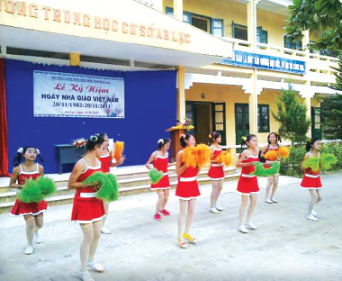
VINABRITA SCHOOL
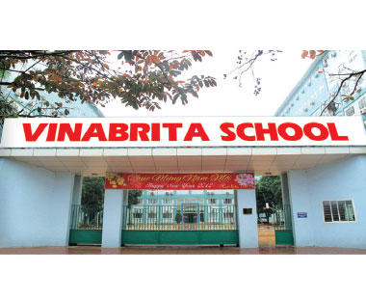

Part III: Free talking (1 pt)
Talk about your dream school.
VIET HUNG SECONDARY SCHOOL  SCHOOL YEAR: 2019 – 2020 | FIRST TERM TEST  SPEAKING TEST – GRADE 6  No 2

Part I: Introduction (0.5 pt)
Introduce yourself (name, age, school, class)
Part II: Interview (0.5 pt)
How many rooms are there in your house?
What is your favourite room?
Part III: Free talking (1 pt)
Imagine that you and your friends are having a picnic this weekend. Talk about your plans for that picnic.

VIET HUNG SECONDARY SCHOOL  SCHOOL YEAR: 2019 – 2020 | SECOND TERM TEST  SPEAKING TEST – GRADE 6  Answer key

Part I: Introduction (0.5 pt)
Introduce yourself (name, age, school, class)
My name is ... I’m …years old. I live … I study at …in class …
Part II: Interview (0.5 pt)
1. What is your favourite subject at school?
+ Maths, literature, history, English, science, PE, physics, …
There are three schools here. Which school would you like to go to? Why?
+ AN LAC LOWER SECONDARY SCHOOL: surrounded by mountains and green fields, there is a school garden,…
+ PLC SYDNEY: a girls’ school, a boarding school,…
+ VINABRITA SCHOOL: an international school, big building and modern equipment, many interesting clubs,…
2. How many rooms are there in your room?
+ There are …… rooms (living room, bathroom, bedroom, …).
What is your favourite room?
+ My favourite room is ……..
Part III: Topic (1 pt)
1. Talk about your dream school
+ Where is that school? Is it in a different town or country?
+ What kind of that school? (a boarding school, a boys’/ girls’ school, an international school,…)
+ What does it have? (a swimming pool, video rooms, a greenhouse or farm,…)
+ What are students’ activities? (join many interesting club, play sports, draw, paint, …)

2. Imagine that you and your friends are having a picnic this weekend. Talk about your plans for that picnic.
+ Where are you having a picnic? (park, zoo, mountain, countryside,…)
+ How are you getting there? (by bus, by coach, by taxi, by bike,…)
+ What are you doing in the morning?
+ What are you doing in the afternoon?

GV ra đề  Lương Thị Hồng Nhung | Tổ nhóm chuyên môn  Nguyễn Bá Thắng | BGH duyệt  Lê Kim Tuyến

